WRITING AN ARM RS-232C DRIVER
FOR
AN RC SYSTEMS 8660 VOICE SYNTHESIZER

Jenner Hanni

Project #1
ECE372
Winter 2013

I affirm that all work herein is solely my own and that I received
no assistance from anyone except the TA and Dr. Hall.

_____________________________________________
Table of Contents

Design Log for Part 1 - Button-driven Talker
First, I wanted to figure out this chip. I read through the RC8660 data sheet from the introduction to the serial interface portion on page 10. I drew the IC diagram of the typical application circuit on page 3 and verified that I understood each line. Then I worked with the RS232 section in the text (page 273-275) and summarized:
8 bit packets, one start bit, one stop bit, no parity bit, LSB first. RC8660 handles up to 115200 and automatically detects. Using the CTS# to control the flow but only have to check it every eight bytes because all data is routed through a high speed 16-byte buffer within the chip before being stored in the main buffer.
The logic level conversion is handled by the MAX202 in circuit.
We can connect RS232 straight through.
The PXA270 has four UARTS. We're using UART B on COM2 (16C554)
and interfacing with the RC8660 speech synthesizer chip.
UART is DTE and RC8660 is DCE.
Usually the standard RS232 procedure is:
DTR# ->
<- DSR#
RTS# ->
<- CTS#
<- CD#
We're not using DSR# and RTS# at all.
The next step is to figure out the actual handshaking procedure.
In this case, the UART 16C554 will have the buffer loaded with ASCII chars when it detects an interrupt - if this was caused by the falling edge on the RC8660 CTS# line, the UART will begin to send the message to the RC8660.
A message consists of a start bit, 8 bits, a stop bit, another start bit, 8 bits, another stop bit, etc. The RC8660 will leave the CTS# line low until the bits are all accepted and then pull the line high. What if the CTS# line is pulled high again during the message?
RxD and TxD are also included in the datasheet and figure 5-19 -- how are they used?
Next, I worked through setting up the interrupt handling, leaving the contents of the button service procedure empty. I looked up the GPIO73 info from the datasheet.
For GPIO73, GPLR2 monitors pin state
GPSR2 status register
GPCR2 control register
GPDR2 set in direction
GRER2 rising edge detect
GFER2 falling edge detect
GEDR2 detect edge type
from Table 24-4 on page 24-11 of datasheet
I want to configure GPIO73 as an input and for rising edge detect. I had the code from my previous project from ECE371 so I walked through that to verify that I still understood it and then I went down and tested it in the lab.
I developed the .data portion. I looked in the RC8660 to find the format for controls, which I converted to hex, and for data, which I left in ascii. I found it difficult to tell which was which if they were all in ascii.
Command syntax in the RC8660 data sheet is on page 20. The default command character (CTRL+A) is 0x01. I decided to go with their recommendation, which is that I use absolute parameters once and then use relative parameters after that.
For example, this string of absolute parameters sets Alvin voice at volume 7:
CTRL+A "9O" CTRL+A "7V" where CTRL+A is also 01
0x01,0x39,0x30,0x01,0x37,0x56
Data syntax appeared to be ridiculously simple. I started with
'This is a test' in ascii. I started with T,a,k,e, ,m,e, t,o, ,y,o,u,r, ,l,e,a,d,e,r to see.
(This is the point where I got excited about the project.)
How to do stop and start bits? (Set them directly in the register.)
I went into the UART B on COM2 to figure out the order of operations for its interface to the speech chip, first the hardware and then the interrupts.
Notes on first read-through:
We're not using a parity bit.
Baud rate supported by RC8660 is 115200 max.
"Selectable receive FIFO trigger levels, selectable TX and RX baud rates, modem
interface controls."
Standard CPU interface or using the bus? I don't know.
Standard CPU 16 Mode
UART Channel B (pg 5-39)
CSA CSB CSC CSD
1 0 1 1
Bus 68 Mode
UART CHannel B (pg 5-40)
-CS A4 A3
0 0 1
I read through the registers twice. No notes. Just thinking about it.
Then I realized that we're writing to the PXA270, not the RC8660! I keep getting this confused. I drew all the physical pieces out on the white board to get it straight.
I read through the UART initialization procedures on pages 275-278 and verified all of the hex and all of the registers. I made up the following algorithm:
INITIALIZE UART B in the external 16C554 using COM2 port:
1. Set baud rate Write to divisor latches
Set divisor bit 7 in LCR to 1
10000011 = 0x83
Choosing baud rate of 38.4k because RC8660 handles it.
DLM 0x00
DLL 0x18
Reset enable bit 7 in LCR to 0.
2. Generate appropriate interrupt signals
In the IER,
set bit 3 for CTS# asserted
set bit 1 for when THR is available
control word: 0x0A
3. Set non-FIFO mode and explicitly clear FIFO
FCR is ISR - how can I be sure I'm writing to the correct register?
In any case, write 0x0 to FCR.
4. Hook IRQ vector, install our IRQ-DIRECTORY procedure.
* Not sure about steps 5 and 6 at this point. Need to verify hex.
*5. Allow interrupt controller to respond to button press on <75>
and UART on <115>
Unmask bit 10 in the IMR
0x40D00004 control word: __________
*6. Enable UART interrupt inside the BUTTON_SVC program so the button
sends the text message to the RC8660.
Now! Having worked out the details of my version of the program, I stepped back to put all the pieces together in an algorithm version using the program in figure 5-27, my interrupt pieces from my buttom program that I know are correct, and the notes I've made up til now about the registers for my GPIO pins.
I realized that the interrupt steps that I have and the ones Dr. Hall has in figure 5-27 didn't entirely agree ... but realized after walking through registers that they were just out of order and order didn't matter for that case, as the values were already written back before the registers were changed.
I also had to step through every register (I made a diagram on the whiteboard) in the button service and talker service portions to be sure I covered the cases in the correct order, and that there weren't any surprises in the text code.
The final version of that was basically sections, which I then drew up in the algorithm/flow chart that's attached. Then I worked through each section, cross-referencing with the book, until I had everything branching correctly. Then I added in the actual register-level comments.
Then I wrote out all the algorithm parts as comments in a .s file.
Before filling in the rest of the actual code to the left of the @ symbols, I went through and changed all the branch names so they were consistent. I verified the process again by walking through each step in the algorithm and making sure all the values were loaded and stored properly. I cleaned up the comments and tried to make them more simple.
Then I printed out the algorithm so far and, starting at the top, I worked through and calculated all the register address values and wrote them in at each step. I then collected them all in a giant list to be defined at the beginning of the program.
I realized that I didn't actually know what the CPSR, ICIP, etc. addresses should be so I went back through the text and reviewed all the interrupt stuff from chapter four, comparing it line by line with the IRQ procedure hook section from ZeusTalker.s on pages 310-312. I made sure to include the BTLDR_IRQ_ADDRESS in the literal pool but I'm still not sure about where CPSR came from.
Then I walked through each section and wrote the code.
I got a little lost in the bit sets and clears and had to use some diagrams to figure out what I was doing. Then I remembered what BIC does. Also had to look up MRS and MSR to make sure Dr Hall's syntax was correct.
I basically used the given #0x83 and #0x18 values for the UART straight from the text. Probably need to check it against the UART datasheet but at this point I just want to see if it works on the first try.
Decided maybe only need R0, R1 and not the extra registers that are called for in Hall's program. Worked out the talker service and realized, no, you need them for the message and counter.
I set the message to be "take me to your leader" and need to go down to the lab to test it. I had a bunch of trouble getting Insight to reliably connect to the Zeus board.
Minor syntactic changes were required like =ICMR, etc. Immediate offsets with #CLRBIT27, etc. The mask xFFF was too big so I had to create an equivalent expression with
MOV R2, #0xFF0
ADD R2, R2, #0xF
Program received signal SIGBUS, Bus error at line 122 so there's something wrong with the bootloader IRQ addressing. Is IRQ_DIRECTOR a constant that needs to be initialized in the same way IRQ_BTLDR_ADDRESS does on the literal pool? Or is it a system-wide thing that can just be out there in the ether? No, IRQ_DIRECTOR is just the procedure of interest and basically I was overwriting the IRQ_BTLDR_ADDRESS. Fixed that.
Next SIGBUS error at line 140, in the section to clear bit 7 in CPSR. Changed syntax to be the same as above. Looked at registers. Possibly a problem with the PC being corrupted so I tried the code from last year and now it has exactly the same problem, but it survives past the error and the PC takes on 0x6000e3cc which is not an increment.
... I ran the program again but chose to step through using assembly instruction stepthrough. It successfully ends up in the LOOP but now just won't recognize the interrupt. TA says it's probably because I haven't remapped the AF for the GPIO pin 73 for the button by using table 24-29 (GAFR2_L Bit Definitions). The value for that register was 0x6aaaaaaa. I made a mask and wrote back to it. New value should be 0x6aa2aaaa, which it is.
Constant SIGBUS errors turned out to be the memory window being too large so I minimized it and tried that way. No change. I made up a list of possible ways to test what was going on:
- Try a B LOOP instead of stepping into LOOP directly - no effect.
- Put a NOOP after the writeback to CPSR - no effect.
- Write a basic simple almost-empty program - works fine.
It looks like the actual problem happens when the program writes the line to CPSR. There’s an immediate interrupt happening but I don’t think I’ve hooked the interrupt properly.

NOTES FROM EMAIL

NOTES FROM PAGE IN BOOK

Stepping through the modified button-driven LED program reveals that ICMR isn't actually being written by this code. I looked at the memory location and the value is still 0x0.

LDR R0, =0x40D00004
LDR R1,[R0]
ORR R1, #0x400
STR R1, [R0]

I have the interrupt controller initialized before the IRQ procedure address is hooked but the book has it the other way. Does it matter? I reversed them and remade it but it still isn't writing. The value in ICMR after the interrupt controller is initialized is still 0x00, and the interrupt fails to recognize the button (as it should, if that interrupt has not been unmasked).

I looked up ICMR in the pub to see maybe if it needs an initialization step that's not in the book. It doesn't.

I recalculated all values and addresses and found my value for clearing bit 20 to be 0x8000 instead of 0x100000 so I changed it accordingly. Also added probably redundant bit assignments to ICCR and ICLR but whatever, I'm tired of Insight not actually telling me the truth about what's in memory locations.

I tested it and .... ?

Interesting problem -- in SEND, the BPL GOBCK isn't preceded by TST in the book.
Button-Driven Talker Flowchart

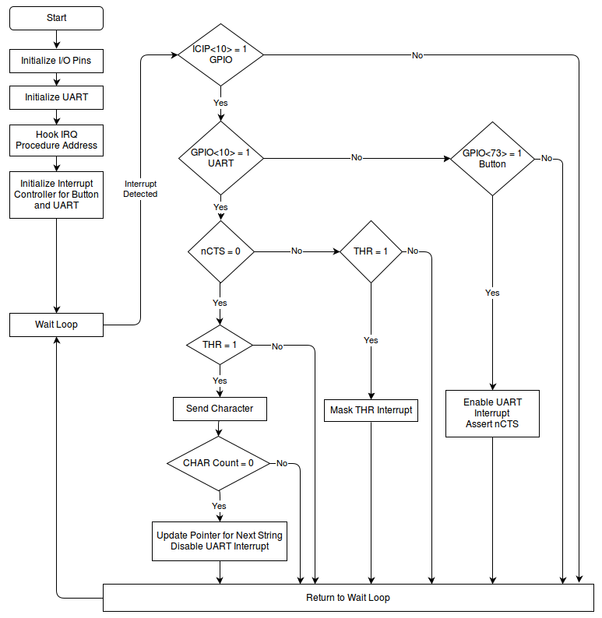
Button-Driven Initial Algorithm
# Initialize GPIO 73 as an input and rising edge detect
Write 0x200 to set bit 9 to 1 in GPCR2 at 0x40E0002C to output a low on GPIO 73.
Write 0x200 to clear bit 9 in GPDR2 at 0x40E00014 to set GPIO 73 as an input.
Write 0x200 to clear bit 9 in GRER2 at 0x40E00038 to set GPIO 73 for rising edge detect.
# Initialize GPIO 10 as a rising edge detect for COM2 UART
Write 0x400 to set bit 10 to 1 in GRER0 at 0x40E00030 to set GPIO 10 for rising edge detect.
# Initialize UART
Write 0x83 to the Line Control Register at 0x10800006 to set asynchronous data communication details. 0x83 = 1000 0011 as calculated below:

Bits 1:0 11 (8-bit character)
Bit 2 0 (1 stop bit)
Bit 3 0 (no parity)
Bit 4:6 0 (ignored, not specified)
Bit 7 1 (access divisor latch registers)
Write a 0x18 to Divisor Latch Low Register at 0x10800000 and 0x00 to the Divisor Latch High Register at 0x10800002 to provide a divisor value of ‘24’ to generate a baud rate of 38.4KB/s.

Write 0x03 to the Line Control Register at 0x10800006 to toggle bit 7 (the DLAB bit) back to 0 to give access to the Transmit and Receive registers for regular operation.
Write 0x0A to the Interrupt Enable Register at 0x10800002 to enable an interrupt on a clear to send request (bit 1) and on a modem status interrupt (bit 3). 0x0A = 0000 1010.
Write 0x00 to the FIFO Control Register at 0x10800004 to write a 0 to bit 0 to both disable and clear the FIFO.
# Hook IRQ procedure address and install our IRQ_DIRECTOR address
Read the current instruction from the IRQ Interrupt Vector Address at 0x18 and mask all but the least significant eight bits (offset bits) of that instruction. Increment those eight bits with 0x20 to build the absolute address of the IRQ procedure in the literal pool.
Read the bootloader IRQ address from the literal pool and store it in a constant for use in the IRQ_DIRECTOR procedure. Load the absolute address of the IRQ_DIRECTOR procedure and store this address in the literal pool.
# Initialize interrupt controller for button and UART on IP<10>
Write 0x400 to the Interrupt Controller Mask Register at 0x40D00004 to write a 1 to bit 10 to unmask an edge detected interrupt on that pin. 0x400 = 0100 0000 0000.
# IRQ_DIRECTOR - An interrupt has been detected! Test it to determine source
Save the necessary registers on the stack.
Test if there’s been an interrupt on pin 10 by checking whether the current value in the Interrupt Controller IRQ Pending Register at 0x40D00000 contains a 1 at bit 10 (0x400).
If no, break to PASSON.
Test if a rising edge has been detected on pin 10 by checking whether the current value in GEDR0 at 0x40E00048 contains a 1 at bit 10 (0x400).
If yes, go send the character using TLKR_SVC.
Test if a rising edge has been detected on pin 73 by checking whether the current value in GEDR2 at 0x40E00050 contains a 1 at bit 9 (0x200).
If yes, go service the button press using BTN_SVC.
# PASSON - The interrupt is not from our button or the UART
Restore the registers and load the PC with the saved bootloader IRQ address.
# BTN_SVC - The interrupt came from our button on GPIO pin 73
Write 0x200 to GEDR2 to clear bit 9 to clear the interrupt from pin 73.
Write 0x0A to the Modem Control Register at 0x10800008 to write a 1 to bit 1 to enable auto-flow mode for auto-CTS and to write a 1 to bit 3 to enable the UART interrupt.
# TLKR_SVC - The interrupt came from the CTS# low or THR empty or other interrupt
Save additional registers. Test if CTS# is currently asserted by checking whether the current value in the Modem Status Register at 0x1080000E contains a 1 at bit 4 (0x10).
If no, check for THR status using NOCTS.
Test if the Transmit Hold Register is empty and ready for use by checking whether the current value in the Line Status Register at 0x1080000A contains a 1 at bit 6 (0x20).
If no, exit and wait for THR-ready to be asserted using GOBCK.
If yes, both are asserted so send the character using SEND.
# NOCTS - The interrupt did not come from CTS# low
Test if Transmit Hold Register is empty and ready for use by checking whether the current value in the Line Status Register at 0x1080000A contains a 1 at bit 6 (0x20).
If no, neither CTS or THR are asserted so GOBCK.
Write 0x08 to the UART Interrupt Enable Register at 0x10800002 to enable the modem status interrupt (bit 3 = 1) and to disable the transmit buffer interrupt (bit 1 = 0).
# SEND - unmask THR, send the character, test if more characters
Write 0x0A to the UART Interrupt Enable Register at 0x10800002 to enable the modem status interrupt (bit 3 = 1) and to enable the transmit buffer interrupt (bit 1 = 1).
Use the address of the CHAR_PTR and the address of the CHAR_COUNT to load the next character in the string, increment the character pointer, and update the CHAR_PTR with the incremented character address.
Write the character to the UART Transmit Holding Register at 0x10800000, which automatically clears the interrupt.
Decrement the character counter by one, then test it to see if it’s greater than zero.
If yes, go get more characters using GOBCK.
If no, reset CHAR_PTR to the string starting address and reset CHAR_COUNT.
Write 0x08 to the Modem Control Register to disable the modem interrupt enable (bit 3 = 0).

# GOBCK - Restore from the interrupt
Restore the additional registers used by TLKR_SVC.
Restore the original registers, including the return address.
Return from the interrupt to the wait loop.
Button-Driven Final Algorithm (working copy)

# Initialize GPIO 73 as an input and rising edge detect
Write 0xC0000 to clear bits 19 and 20 in GAFR2_L at 0x40E00064 to disable alternate functions.
Write 0x200 to set bit 9 to 1 in GPCR2 at 0x40E0002C to output a low on GPIO 73.
Write 0x200 to set bit 9 to 0 in GPDR2 at 0x40E00014 to set GPIO 73 as an input.
Write 0x200 to set bit 9 to 1 in GRER2 at 0x40E00038 to set GPIO 73 for rising edge detect.
# Initialize GPIO 10 as a rising edge detect for COM2 UART
Write 0x400 to set bit 10 to 1 in GRER0 at 0x40E00030 to set GPIO 10 for rising edge detect.
# Initialize UART
Write 0x83 to the Line Control Register at 0x10800006 to set asynchronous data communication details. 0x83 = 1000 0011 as calculated below:

Bits 1:0 11 (8-bit character)
Bit 2 0 (1 stop bit)
Bit 3 0 (no parity)
Bit 4:6 0 (ignored, not specified)
Bit 7 1 (access divisor latch registers)
Write a 0x18 to Divisor Latch Low Register at 0x10800000 and 0x00 to the Divisor Latch High Register at 0x10800002 to provide a divisor value of ‘24’ to generate a baud rate of 38.4KB/s.

Write 0x03 to the Line Control Register at 0x10800006 to toggle bit 7 (the DLAB bit) back to 0 to give access to the Transmit and Receive registers for regular operation.
Write 0x00 to the FIFO Control Register at 0x10800004 to write a 0 to bit 0 to both disable and clear the FIFO.
# Hook IRQ procedure address and install our IRQ_DIRECTOR address
Read the current instruction from the IRQ Interrupt Vector Address at 0x18 and mask all but the least significant eight bits (offset bits) of that instruction. Increment those eight bits with 0x20 to build the absolute address of the IRQ procedure in the literal pool.
Read the bootloader IRQ address from the literal pool and store it in a constant for use in the IRQ_DIRECTOR procedure. Load the absolute address of the IRQ_DIRECTOR procedure and store this address in the literal pool.
# Initialize interrupt controller for button and UART on IP<10>
Write 0x01 to the Interrupt Controller Control Register at 0x40D00014 to write a DIM bit to allow only unmasked interrupts as defined in the ICMR to bring the processor out of idle mode.

Write 0x400 to the Interrupt Controller Mask Register at 0x40D00004 to write a 1 to bit 10 to unmask an edge detected interrupt on that pin. 0x400 = 0100 0000 0000.

Write 0x00 to the Interrupt Controller Level Register at 0x40D00008 to set everything for an IRQ.
Write 0x80 to the Current Program Status Register at CPSR to clear bit 7 to enable IRQ Interrupts on the processor.

# LOOP

Loop while waiting for an interrupt.

# IRQ_DIRECTOR - An interrupt has been detected! Test it to determine source
Save the necessary registers on the stack.
Test if there’s been an interrupt on IP pin 10 by checking whether the current value in the Interrupt Controller IRQ Pending Register at 0x40D00000 contains a 1 at bit 10 (0x400).

If no, break to PASSON.
Test if a rising edge has been detected on GPIO pin 10 (UART interrupt) by checking whether the current value in GEDR0 at 0x40E00048 contains a 1 at bit 10 (0x400).
If yes, go send the character using TLKR_SVC.
Test if a rising edge has been detected on GPIO pin 73 (button interrupt) by checking whether the current value in GEDR2 at 0x40E00050 contains a 1 at bit 9 (0x200).
If yes, go service the button press using BTN_SVC.
Fall through to PASSON.
# PASSON - The interrupt is not from our button or the UART
Restore the registers and load the PC with the saved bootloader IRQ address.
# BTN_SVC - The interrupt came from our button on GPIO pin 73
Write 0x200 to GEDR2 to write a 1 to bit 9 to clear the interrupt from GPIO pin 73.
Write 0x0A to the Interrupt Enable Register at 0x10800002 to enable an interrupt on a clear to send request (bit 1) and on a modem status interrupt (bit 3). 0x0A = 0000 1010.
Write 0x0A to the Modem Control Register at 0x10800008 to write a 1 to bit 1 to enable auto-flow mode for auto-CTS and to write a 1 to bit 3 to enable the UART interrupt.
Restore registers and return to wait loop.
# TLKR_SVC - The interrupt came from the CTS# low or THR empty or other interrupt
Save additional registers. Test if CTS# is currently asserted by checking whether the current value in the Modem Status Register at 0x1080000E contains a 1 at bit 4 (0x10).
If no, check for THR status using NOCTS.
Test if the Transmit Hold Register is empty and ready for use by checking whether the current value in the Line Status Register at 0x1080000A contains a 1 at bit 6 (0x40).
If no, exit and wait for THR-ready to be asserted using GOBCK.
If yes, both are asserted so send the character using SEND.
# NOCTS - The interrupt did not come from CTS# low
Test if Transmit Hold Register is empty and ready for use by checking whether the current value in the Line Status Register at 0x1080000A contains a 1 at bit 6 (0x40).
If no, neither CTS or THR are asserted so GOBCK.
Write 0x08 to the UART Interrupt Enable Register at 0x10800002 to enable the modem status interrupt (bit 3 = 1) and to disable the transmit buffer interrupt (bit 1 = 0) to mask THR interrupt.

Restore registers and return to wait loop.
# SEND - unmask THR, send the character, test if more characters
Write 0x0A to the UART Interrupt Enable Register at 0x10800002 to enable the modem status interrupt (bit 3 = 1) and to enable the transmit buffer interrupt (bit 1 = 1).
Use the address of the CHAR_PTR and the address of the CHAR_COUNT to load the next character in the string, increment the character pointer, and update the CHAR_PTR with the incremented character address.
Write the character to the UART Transmit Holding Register at 0x10800000, which automatically clears the interrupt.
Decrement the character counter by one, then test it to see if it’s greater than zero.
If yes, go get more characters using GOBCK.
If no, reset CHAR_PTR to the string starting address and reset CHAR_COUNT.
Write 0x08 to the Modem Control Register to disable the modem interrupt enable (bit 3 = 0).

Restore registers and return to wait loop.

# GOBCK - Restore from the interrupt
Restore the additional registers used by TLKR_SVC.
Restore the original registers, including the return address.
Return from the interrupt to the wait loop.
Button-Driven Final Code
Design Log for RTC-Driven Talker
To add the RTC, I returned to the flowchart and looked at how to change it, specifically my question was: how does the RTC itself trigger an interrupt. I walked through the steps in seconds.s and made the new flowchart.
Then I took the section headings from the button-driven talker algorithm and filled them in with the steps I think I need to add for the RTC. Initializing the interrupt controller requires an additional unmasking of bit 31 for the RTC alarm interrupt. The unmasking of bit 10 is the same.

I realized that the RTC alarm is initialized correctly but BTN_SVC should actually set the bits in the RTSR to enable the interrupt only after the button has been pressed.

The RTC is described in section 21 of the PXA270 Developer's Manual. I decided to use the timer functionality because it seemed most simple. The resolution is one second.

RCNR = counter register
RTAR = alarm register
RTSR[0] = alarm detect
RTSR[2] = alarm enable

Initialization set RTAR to 60 for sixty seconds (0x3C)
on button press write 0x04 to enable the alarm using RTSR[2]
write 0x00 to reset RCNR value to zero
on RTC_SVC reset the alarm at RTSR[0] by writing 1 (0x01)
reset the RCNR to zero to restart the counter comparison
Then I wrote out the initial complete algorithm using my previous program as a base. The flowchart basically calls for two more subroutines -- GPIO_SVC and RTC_SVC.
Next I had to verify the word for ICMR, the oscillator configuration register, to set bit 3: 0x08

Should the button reset others if it's in mid-stream? Decided no.
Modified the flowchart, made adjustments.

Realized I wasn't restoring registers properly from the different sections so I had to go back and make sure I was saving and restoring properly in each service routine.

The initial algorithm was done so I went down to test it.
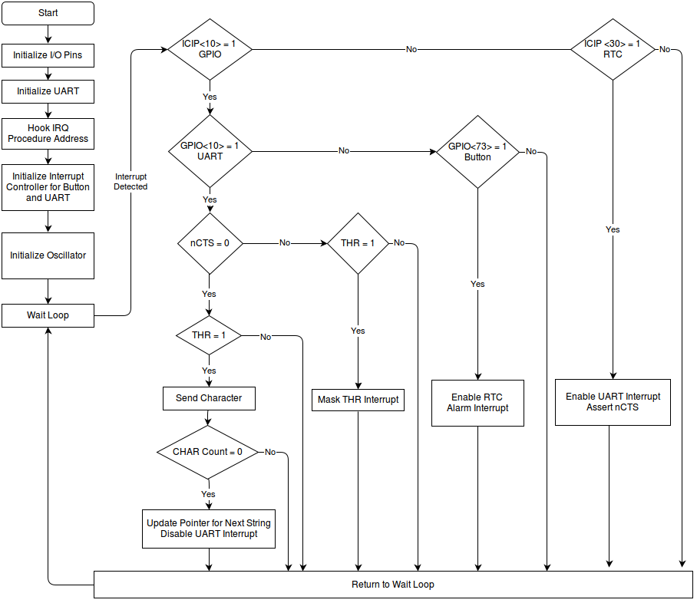
Repeating Talker Flowchart
Initial Repeating Talker High-Level Algorithm
# Initialize GPIO 73 as an input and rising edge detect
Write 0xC0000 to clear bits 19 and 20 in GAFR2_L at 0x40E00064 to disable the alternate function.
Write 0x200 to set bit 9 to 1 in GPCR2 at 0x40E0002C to output a low on GPIO 73.
Write 0x200 to set bit 9 to 1 in GPDR2 at 0x40E00014 to set GPIO 73 as an input.
Write 0x200 to set bit 9 to 1 in GRER2 at 0x40E00038 to set GPIO 73 for rising edge detect.
# Initialize GPIO 10 (COM2 UART) as a rising edge detect
Write 0x400 to set bits 10 to 1 in GRER0 at 0x40E00030 to enable rising edge detect.
# Initialize UART
Write 0x83 to the Line Control Register at 0x10800006 to set asynchronous data communication details. 0x83 = 1000 0011 as calculated below:

Bits 1:0 11 (8-bit character)
Bit 2 0 (1 stop bit)
Bit 3 0 (no parity)
Bit 4:6 0 (ignored, not specified)
Bit 7 1 (access divisor latch registers)
Write a 0x18 to Divisor Latch Low Register at 0x10800000 and 0x00 to the Divisor Latch High Register at 0x10800002 to provide a divisor value of ‘24’ to generate a baud rate of 38.4KB/s.

-

Write 0x03 to the Line Control Register at 0x10800006 to toggle bit 7 (the DLAB bit) back to 0 to give access to the Transmit and Receive registers for regular operation.
Write 0x00 to the FIFO Control Register at 0x10800004 to write a 0 to bit 0 to both disable and clear the FIFO.
# Hook IRQ procedure address and install our IRQ_DIRECTOR address
Read the current instruction from the IRQ Interrupt Vector Address at 0x18 and mask all but the least significant eight bits (offset bits) of that instruction. Increment those eight bits with 0x20 to build the absolute address of the IRQ procedure in the literal pool.
Read the bootloader IRQ address from the literal pool and store it in a constant for use in the IRQ_DIRECTOR procedure. Load the absolute address of the IRQ_DIRECTOR procedure and store this address in the literal pool.
# Set the oscillator controller to use 32.768 kHz oscillator and enable RTC Alarm Interrupt

Write 0x08 to set bit 3 in the Oscillator Configuration Register (OSCC) at 0x41300008 to enable output at processor oscillator speed of 13 MHz.
Write 0x3C to set the RTC Alarm Register (RTAR) at 0x40900004 for a decimal value of 60 seconds.
# Initialize interrupt controller for button and UART on IP<10> and the RTC on IP<31>
Write 0x01 to the Interrupt Controller Control Register at 0x40D00014 to write a DIM bit to allow only unmasked interrupts as defined in the ICMR to bring the processor out of idle mode.

Write 0x80000400 to the Interrupt Controller Mask Register at 0x40D00004 to write a 1 to bits 10 to 31 to unmask an edge detected interrupt on those pins.

0x8000 0400 = 1000 0000 0000 0000 0000 0100 0000 0000

Write 0x00 to the Interrupt Controller Level Register at 0x40D00008 to set everything to create IRQ.
# IRQ_DIRECTOR - An interrupt has been detected! Test it to determine source
Save the necessary registers on the stack.
Test if there’s been an interrupt on pin 10 by checking whether the current value in the Interrupt Controller IRQ Pending Register at 0x40D00000 contains a 1 at bit 10 (0x400).

If yes, break to GPIO_SVC.
Test if there’s been an interrupt on pin 31 by checking whether the current value in the Interrupt Controller IRQ Pending Register at 0x40D00000 contains a 1 at bit 31 (0x80000000).

If no, break to PASSON.
If yes, break to RTC_SVC.
# GPIO_SVC - The interrupt might have come from our button or the UART

Test if a rising edge has been detected on pin 10 (UART) by checking whether the current value in GEDR0 at 0x40E00048 contains a 1 at bit 10 (0x400).
If yes, go send the character using TLKR_SVC.
Test if a rising edge has been detected on pin 73 (button) by checking whether the current value in GEDR2 at 0x40E00050 contains a 1 at bit 9 (0x200).
If yes, go service the button press using BTN_SVC.

If neither, fall through to PASSON.
# PASSON - The interrupt is not from our button or the UART
Restore the registers and load the PC with the saved bootloader IRQ address.
# BTN_SVC - The interrupt came from our button on GPIO pin 73
Write 0x200 to GEDR2 to write a 1 to bit 9 to clear the interrupt from pin 73.

Write 0x04 to set bit 2 in the RTC Status Register (RTSR) at 0x40900008 to enable alarm interrupt.

Write 0x00 to reset the RTC Counter Register (RCNR) at 0x40900000 to restart the count compare.
# RTC_SVC - The interrupt came from the RTC alarm because it's been sixty seconds.

Write 0x01 to set bit 0 to 1 to clear the alarm in the RTC Status Register (RTSR) at 0x40900008.

Write 0x00 to reset the RTC Counter Register (RCNR) at 0x40900000 to restart the count compare.

Write 0x0A to the Interrupt Enable Register at 0x10800002 to enable an interrupt on a clear to send request (bit 1) and on a modem status interrupt (bit 3). 0x0A = 0000 1010.
Write 0x0A to the Modem Control Register at 0x10800008 to write a 1 to bit 1 to enable auto-flow mode for auto-CTS and to write a 1 to bit 3 to enable the UART interrupt.
# TLKR_SVC - The interrupt came from the CTS# low or THR empty or other interrupt
Save additional registers. Test if CTS# is currently asserted by checking whether the current value in the Modem Status Register at 0x1080000E contains a 1 at bit 4 (0x10).
If no, check for THR status using NOCTS.
Test if the Transmit Hold Register is empty and ready for use by checking whether the current value in the Line Status Register at 0x1080000A contains a 1 at bit 6 (0x20).
If no, exit and wait for THR-ready to be asserted using GOBCK.
If yes, both are asserted so send the character using SEND.
# NOCTS - The interrupt did not come from CTS# low
Test if Transmit Hold Register is empty and ready for use by checking whether the current value in the Line Status Register at 0x1080000A contains a 1 at bit 6 (0x20).
If no, neither CTS or THR are asserted so GOBCK.
Write 0x08 to the UART Interrupt Enable Register at 0x10800002 to enable the modem status interrupt (bit 3 = 1) and to disable the transmit buffer interrupt (bit 1 = 0).
# SEND - unmask THR, send the character, test if more characters
Write 0x0A to the UART Interrupt Enable Register at 0x10800002 to enable the modem status interrupt (bit 3 = 1) and to enable the transmit buffer interrupt (bit 1 = 1).
Use the address of the CHAR_PTR and the address of the CHAR_COUNT to load the next character in the string, increment the character pointer, and update the CHAR_PTR with the incremented character address.
Write the character to the UART Transmit Holding Register at 0x10800000, which automatically clears the interrupt.
Decrement the character counter by one, then test it to see if it’s greater than zero.
If yes, go get more characters using GOBCK.
If no, reset CHAR_PTR to the string starting address and reset CHAR_COUNT.
Write 0x08 to the Modem Control Register to disable the modem interrupt enable (bit 3 = 0).

# GOBCK - Restore from the interrupt
Restore the additional registers used by TLKR_SVC.
Restore the original registers, including the return address.
Return from the interrupt to the wait loop.

Repeating Talker Final Complete Algorithm (working copy)
# Initialize GPIO 73 as an input and rising edge detect
Write 0xC0000 to clear bits 19 and 20 in GAFR2_L at 0x40E00064 to disable the alternate function.
Write 0x200 to set bit 9 to 1 in GPCR2 at 0x40E0002C to output a low on GPIO 73.
Write 0x200 to set bit 9 to 1 in GPDR2 at 0x40E00014 to set GPIO 73 as an input.
Write 0x200 to set bit 9 to 1 in GRER2 at 0x40E00038 to set GPIO 73 for rising edge detect.
# Initialize GPIO 10 (COM2 UART) as a rising edge detect
Write 0x400 to set bits 10 to 1 in GRER0 at 0x40E00030 to enable rising edge detect.
# Initialize UART
Write 0x83 to the Line Control Register at 0x10800006 to set asynchronous data communication details. 0x83 = 1000 0011 as calculated below:

Bits 1:0 11 (8-bit character)
Bit 2 0 (1 stop bit)
Bit 3 0 (no parity)
Bit 4:6 0 (ignored, not specified)
Bit 7 1 (access divisor latch registers)
Write a 0x18 to Divisor Latch Low Register at 0x10800000 and 0x00 to the Divisor Latch High Register at 0x10800002 to provide a divisor value of ‘24’ to generate a baud rate of 38.4KB/s.

-

Write 0x03 to the Line Control Register at 0x10800006 to toggle bit 7 (the DLAB bit) back to 0 to give access to the Transmit and Receive registers for regular operation.
Write 0x00 to the FIFO Control Register at 0x10800004 to write a 0 to bit 0 to both disable and clear the FIFO.
# Hook IRQ procedure address and install our IRQ_DIRECTOR address
Read the current instruction from the IRQ Interrupt Vector Address at 0x18 and mask all but the least significant eight bits (offset bits) of that instruction. Increment those eight bits with 0x20 to build the absolute address of the IRQ procedure in the literal pool.
Read the bootloader IRQ address from the literal pool and store it in a constant for use in the IRQ_DIRECTOR procedure. Load the absolute address of the IRQ_DIRECTOR procedure and store this address in the literal pool.
# Set the oscillator controller to use 32.768 kHz oscillator and enable RTC Alarm Interrupt

Write 0x08 to set bit 3 in the Oscillator Configuration Register (OSCC) at 0x41300008 to enable output at processor oscillator speed of 13 MHz.
Write 0x3C to set the RTC Alarm Register (RTAR) at 0x40900004 for a decimal value of 60 seconds.
# Initialize interrupt controller for button and UART on IP<10> and the RTC on IP<31>
Write 0x01 to the Interrupt Controller Control Register at 0x40D00014 to write a DIM bit to allow only unmasked interrupts as defined in the ICMR to bring the processor out of idle mode.

Write 0x80000400 to the Interrupt Controller Mask Register at 0x40D00004 to write a 1 to bits 10 to 31 to unmask an edge detected interrupt on those pins.

0x8000 0400 = 1000 0000 0000 0000 0000 0100 0000 0000

Write 0x00 to the Interrupt Controller Level Register at 0x40D00008 to set everything to create IRQ.
# IRQ_DIRECTOR - An interrupt has been detected! Test it to determine source
Save the necessary registers on the stack.
Test if there’s been an interrupt on pin 10 by checking whether the current value in the Interrupt Controller IRQ Pending Register at 0x40D00000 contains a 1 at bit 10 (0x400).

If yes, break to GPIO_SVC.
Test if there’s been an interrupt on pin 31 by checking whether the current value in the Interrupt Controller IRQ Pending Register at 0x40D00000 contains a 1 at bit 31 (0x80000000).

If no, break to PASSON.
If yes, break to RTC_SVC.
# GPIO_SVC - The interrupt might have come from our button or the UART

Test if a rising edge has been detected on pin 10 (UART) by checking whether the current value in GEDR0 at 0x40E00048 contains a 1 at bit 10 (0x400).
If yes, go send the character using TLKR_SVC.
Test if a rising edge has been detected on pin 73 (button) by checking whether the current value in GEDR2 at 0x40E00050 contains a 1 at bit 9 (0x200).
If yes, go service the button press using BTN_SVC.

If neither, fall through to PASSON.
# PASSON - The interrupt is not from our button or the UART
Restore the registers and load the PC with the saved bootloader IRQ address.
# BTN_SVC - The interrupt came from our button on GPIO pin 73
Write 0x200 to GEDR2 to write a 1 to bit 9 to clear the interrupt from pin 73.

Write 0x04 to set bit 2 in the RTC Status Register (RTSR) at 0x40900008 to enable alarm interrupt.

Write 0x00 to reset the RTC Counter Register (RCNR) at 0x40900000 to restart the count compare.
# RTC_SVC - The interrupt came from the RTC alarm because it's been sixty seconds.

Write 0x01 to set bit 0 to 1 to clear the alarm in the RTC Status Register (RTSR) at 0x40900008.

Write 0x00 to reset the RTC Counter Register (RCNR) at 0x40900000 to restart the count compare.

Write 0x0A to the Interrupt Enable Register at 0x10800002 to enable an interrupt on a clear to send request (bit 1) and on a modem status interrupt (bit 3). 0x0A = 0000 1010.
Write 0x0A to the Modem Control Register at 0x10800008 to write a 1 to bit 1 to enable auto-flow mode for auto-CTS and to write a 1 to bit 3 to enable the UART interrupt.
# TLKR_SVC - The interrupt came from the CTS# low or THR empty or other interrupt
Save additional registers. Test if CTS# is currently asserted by checking whether the current value in the Modem Status Register at 0x1080000E contains a 1 at bit 4 (0x10).
If no, check for THR status using NOCTS.
Test if the Transmit Hold Register is empty and ready for use by checking whether the current value in the Line Status Register at 0x1080000A contains a 1 at bit 6 (0x20).
If no, exit and wait for THR-ready to be asserted using GOBCK.
If yes, both are asserted so send the character using SEND.
# NOCTS - The interrupt did not come from CTS# low
Test if Transmit Hold Register is empty and ready for use by checking whether the current value in the Line Status Register at 0x1080000A contains a 1 at bit 6 (0x20).
If no, neither CTS or THR are asserted so GOBCK.
Write 0x08 to the UART Interrupt Enable Register at 0x10800002 to enable the modem status interrupt (bit 3 = 1) and to disable the transmit buffer interrupt (bit 1 = 0).
# SEND - unmask THR, send the character, test if more characters
Write 0x0A to the UART Interrupt Enable Register at 0x10800002 to enable the modem status interrupt (bit 3 = 1) and to enable the transmit buffer interrupt (bit 1 = 1).
Use the address of the CHAR_PTR and the address of the CHAR_COUNT to load the next character in the string, increment the character pointer, and update the CHAR_PTR with the incremented character address.
Write the character to the UART Transmit Holding Register at 0x10800000, which automatically clears the interrupt.
Decrement the character counter by one, then test it to see if it’s greater than zero.
If yes, go get more characters using GOBCK.
If no, reset CHAR_PTR to the string starting address and reset CHAR_COUNT.
Write 0x08 to the Modem Control Register to disable the modem interrupt enable (bit 3 = 0).

# GOBCK - Restore from the interrupt
Restore the additional registers used by TLKR_SVC.
Restore the original registers, including the return address.
Return from the interrupt to the wait loop.

Repeating Talker Code

